FULL HD PTZ CAMERA
User Manual
（V1.0）
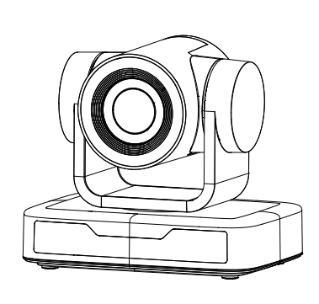

- Attentions

This manual introduces functions, installations and operations for this PTZ camera in details. Please read this manual carefully before installation and use.

1. Cautions
1.1 Avoid damage to product caused by heavy pressure, strong vibration or immersion during transportation, storage and installation.
1.2 Housing of this product is made of organic materials. Do not expose it to any liquid, gas or solids which may corrode the shell.
1.3 Do not expose the product to rain or moisture.
1.4 To prevent the risk of electric shock, do not open the case. Installation and maintenance should only be carried out by qualified technicians.
1.5 Do not use the product beyond the specified temperature, humidity or power supply specifications.
1.6 Wipe it with a soft, dry cloth when cleaning the camera lens. Wipe it gently with a mild detergent if needed. Do not use strong or corrosive detergents to avoid scratching the lens and affecting the image;
1.7 This product contains no parts which can be maintained by users themselves. Any damage caused by dismantling the product by user without permission is not covered by warranty.

2. Electrical Safety
Installation and use of this product must strictly comply with local electrical safety standards.
The power supply of the product is ±12V, the max electrical current is 2A.
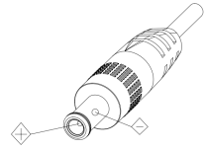

3. Install
  - Do not rotate the camera head violently, otherwise it may cause mechanical failure.
  - This product should be placed on a stable desktop or other horizontal surface. Do not install the product obliquely, otherwise it may display inclined image;
  - Ensure there are no obstacles within rotation range of the holder.
  - Do not power on before completely installation.

4. Magnetic Interference
Electromagnetic fields at specific frequencies may affect the video image. This product is Class A. It may cause radio interference in household application. Appropriate measure is required.

Content
1. Camera Installation 3
1.1.Camera Introduction 3
1.2 Power-on Initial Configuration 3
1.3 Video Output 4
1.4 Mounting Brackets 4
2. Product Overview 6
2.1 Product Introduction 6
2.1.1 Model 6
2.1.2 Dimension 6
2.1.3 Accessory 7
2.2 Main Features 7
2.3 Technical Parameter 8
2.4 Interface Instruction 9
2.4.1 External Interface 9
2.4.2 RS-232 Interface 10
3. Application Instruction 12
3.1 Video Output 12
3.1.1 Power-On Initial Configuration 12
3.1.2 Video Output 12
3.2 Remote Control 13
3.2.1 Keys Introduction 13
3.3 Menu Introduction 16
3.3.1 Main Menu 16
3.3.2 System Setting 16
3.3.3 Camera Setting 17
3.3.4 P/T/Z 20
3.3.5 Version 21
4. Serial Port Communication and Control 22
4.1 VISCA Protocol list 22
4.1.1 VISCA Protocol Return Command 22
4.1.2 VISCA Protocol Control Command 22
4.1.3 VISCA Protocol Inquiry Command 25
4.2 Pelco-D Protocol Command List 27
4.3 Pelco-P Protocol Command List 27
5. Maintenance and Troubleshooting 28
5.1 Camera Maintenance 28
5.2 Troubleshooting 28
6. Copyright Statement 29

1. Camera Installation

Camera Introduction
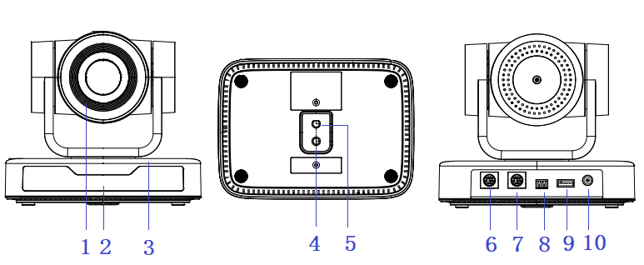
Figure 1.1 Product Interfaces
1. Camera Lens | 5. Screw Hole for Tripod | 9. USB 2.0 Interface
2. Remote Control Receiving Indicator | 6. RS232 Control Interface（Input） | 10. DC12V Input Power Supply Socket
3. Camera Base | 7. RS232 Control Interface（Output）
4. Tripod Screw Hole | 8. RS485 Input (left +, right-)

1.2 Power-on Initial Configuration
1) Power-on: Connect DC12V power supply adapter with power supply socket
2) Initial Configuration: The remote control receiving indicator flashes after power on, the pan-tilt turns left to the lowest left to the lowest, and then turns to the HOME position (both the horizontal and vertical positions are in the middle), while the movement first shrinks and then stretches. When remote control receiving indicator stops flashing, the self-checking is completed.

Notes:
- After power on and self-checking, the camera will automatically return to the preset 0 position if it’s pre-set.
- The default address for the IR remote control is 1#. If the menu restored to factory defaults, the remote control default address will restore to 1#.

1.3 Video Output
USB2.0 Video Output

a. USB 2.0 video cable connection: as shown in Figure1.1 label 9
b. Connect the camera and the computer via USB2.0 video cable, open the video software and select the image device to output the video.

1.4 Mounting Brackets
Notes: Ceiling or wall mounting brackets can only be mounted on template and concrete wall.
For safety reason, plasterboard is not recommended.
- Wall Mounting:
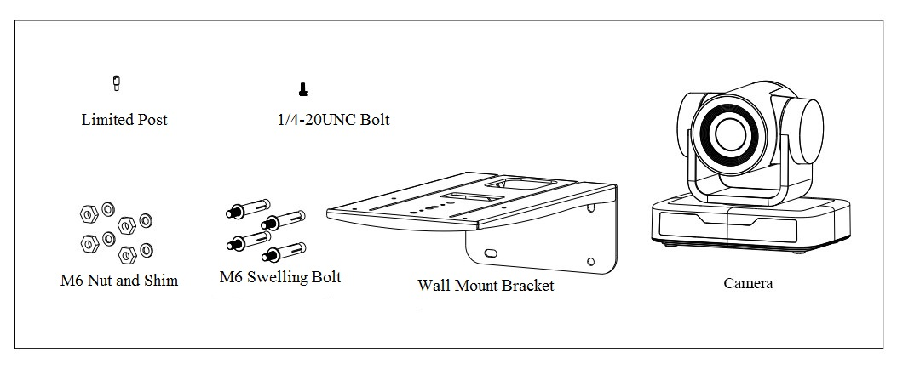
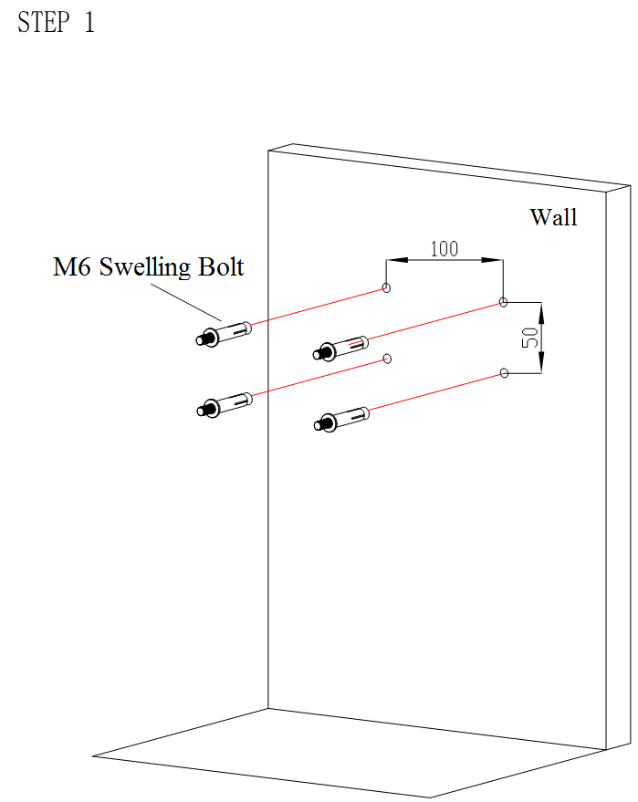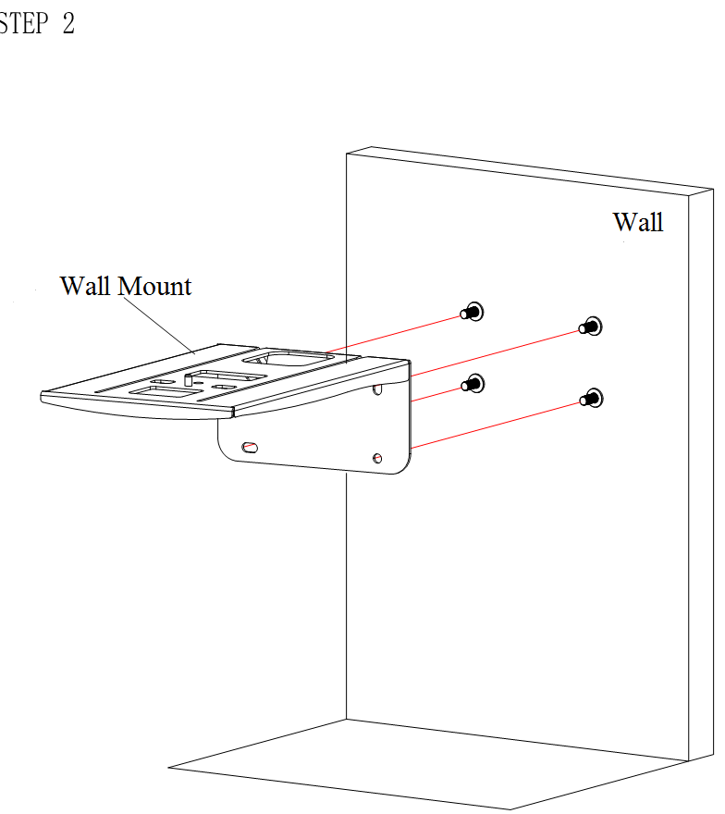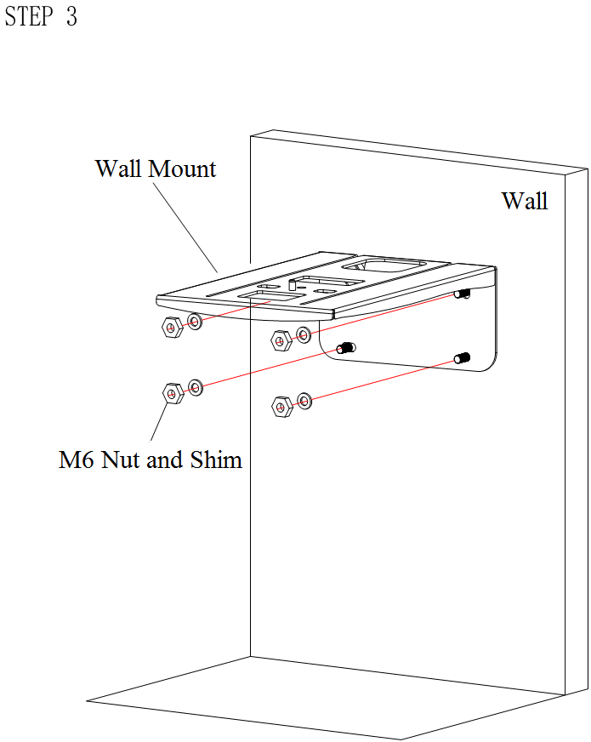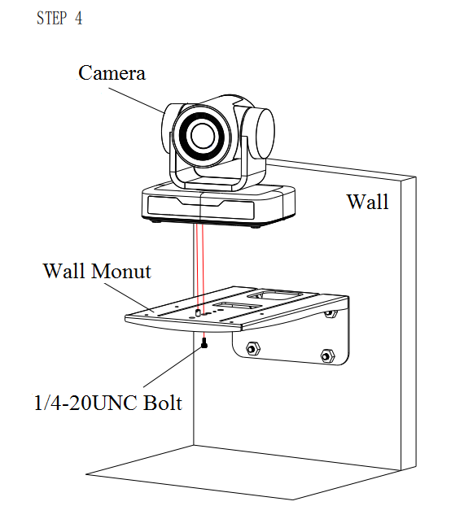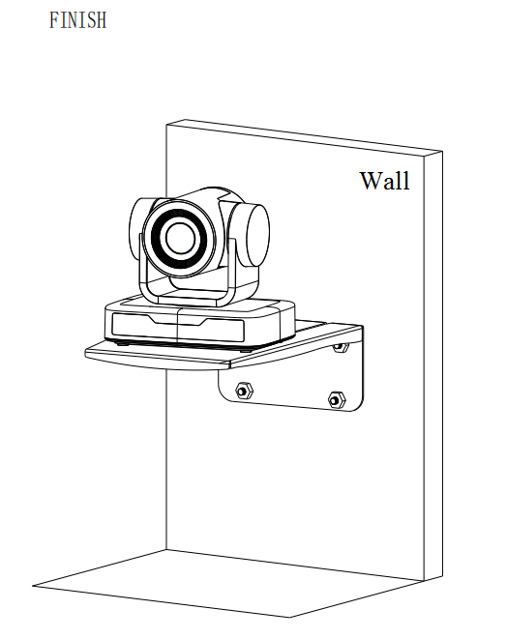

- Ceiling Mounting
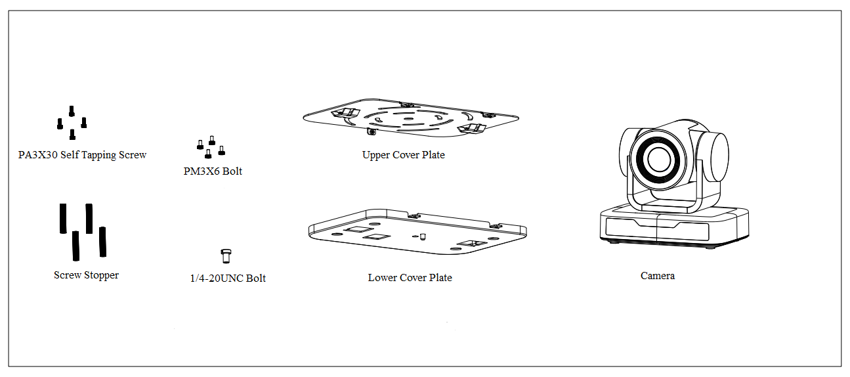

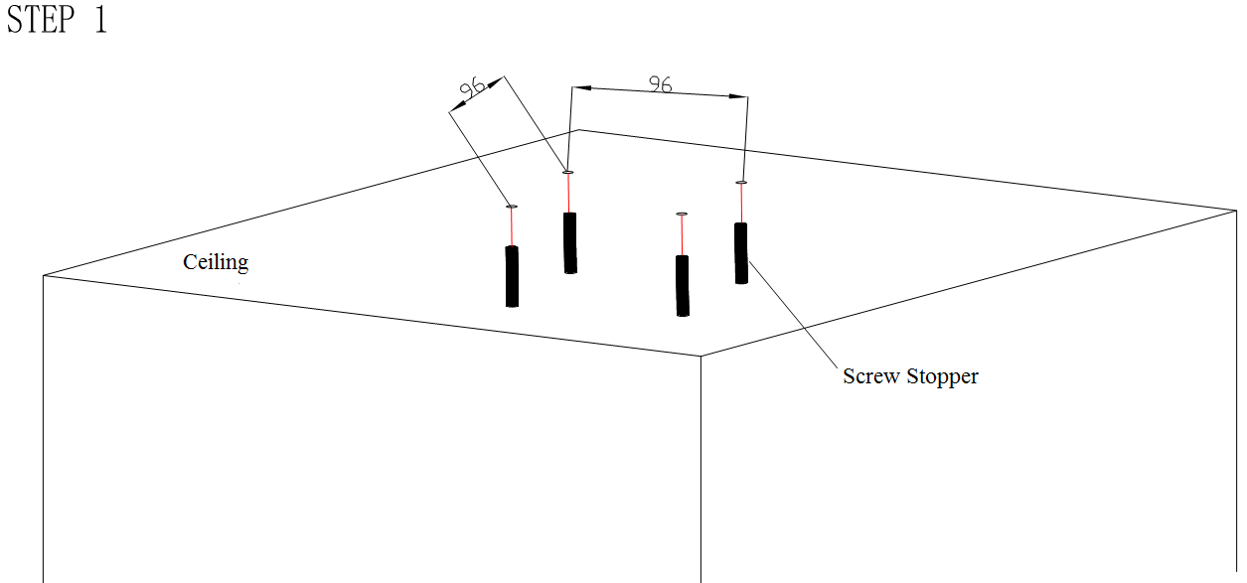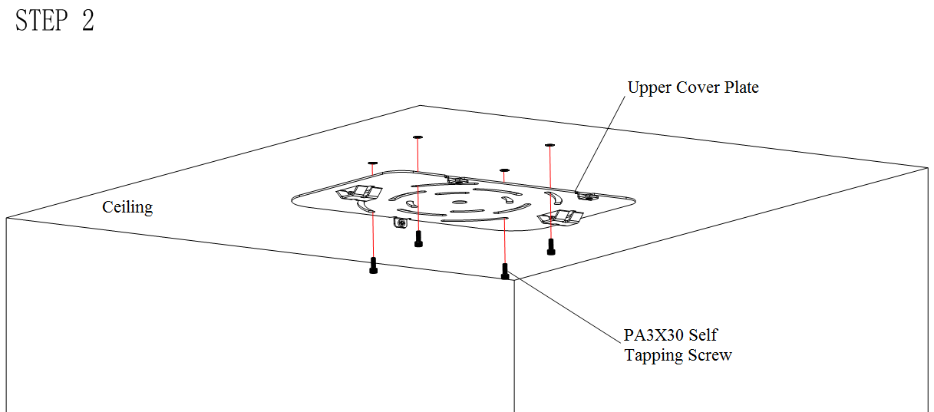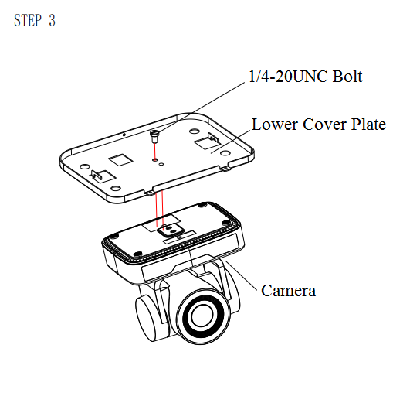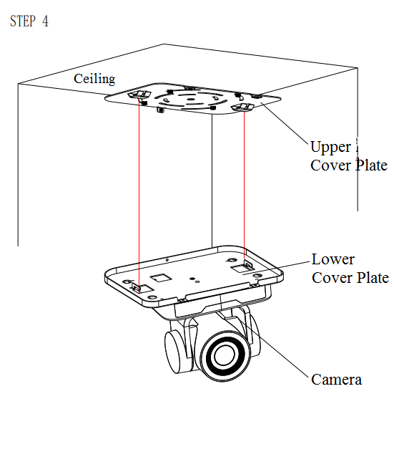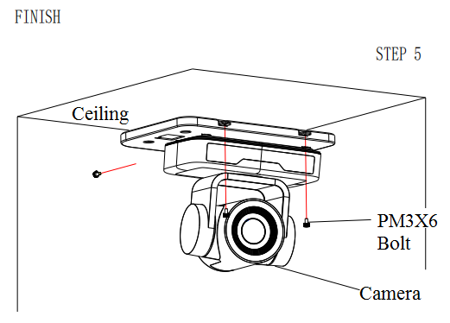

2. Product Overview

2.1 Product Introduction

2.1.1 Model

Model No.X — XXX

10---10X Optical Zoom Lens

Figure 2.1 Product Model

2.1.2 Dimension
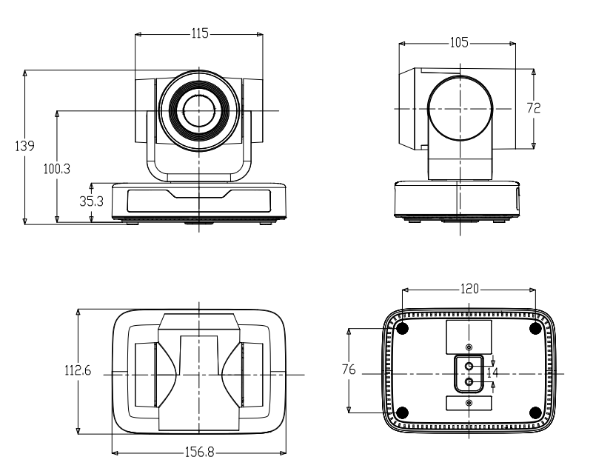

Figure 2.2 Product Dimension

2.1.3 Accessory
Please check below standard and optional accessories when unpacking the box.
Standard Accessory | Optional Accessory
Power adapter | Wall Mount
IR Remote Control | Ceiling Mount
RS232 Cable
User Manual
USB2.0 Cable

USB2.0 video cable: If USB2.0 video cable is required for power supply without power adapter, in which power is supplied by red end and USB video signal is transmitted by black end; if power adapter is used, USB2.0 video cable is not required for power supply, and ordinary USB2.0 video cable is enough.

2.2 Main Features
This series camera has perfect functions, superior performance and rich video output interfaces; Featuring with advanced ISP processing algorithms, offering vivid and high resolution video with a strong sense of depth and fantastic color rendition.
- Full HD Resolution: 1/2.9 inch high quality CMOS sensor. Resolution is up to 1920x1080 with frame rate up to 30 fps.
- Multiple Optical Zoom Lens: 3X/10X optical zoom lens.
- Leading Auto Focus Technology: Fast, accurate and stable auto focusing technology.
- Low Noise and High SNR: Super high SNR image is achieved with low noise CMOS. Advanced 2D/3D noise reduction technology further reduces the noise while ensuring high image clarity.
- Control Interface: RS485, RS232 (cascade connection)
- Multiple Control Protocol: Support VISCA, PELCO-D, PELCO-P protocols; Support automatic identification protocols.
- Quiet Pan / Tilt Movement: With high accuracy step driving motor, camera can pan / tilt extremely quiet and smooth.
- Multiple presets: Up to 255 presets (10 presets via remote control).
- Multiple Application: Online-education, Lecture Capture, Webcasting, Video conferencing, Tele-medicine, Unified Communication, Emergency command and control systems, etc.

2.3 Technical Parameter
Model | 10X
Camera Parameter
Sensor | 1/2.9 inch high quality CMOS sensor
Effective Pixels | 2.07 megapixel, 16：9
Video Format | H264/MJPG:1920*1080P@30/25/20/15/10/5fps；1280*720P@30/25/20/15/10/5fps；960*540@30/25/20/15/10/5fps；800*600@30/25/20/15/10/5fps；720*576@30/25/20/15/10/5fps；720*480@30/25/20/15/10/5fps；640*480@30/25/20/15/10/5fps；640*360@30/25/20/15/10/5fps；352*288@30/25/20/15/10/5fps；320*240@30/25/20/15/10/5fps；  YUY2:1920*1080P@5fps；1280*720@10/5fps；1024*576@15/10/5fps；800*600@20/15/10/5fps；800*448@25/20/15/10/5fps；640*480@30/25/20/15/10/5fps；640*360@30/25/20/15/10/5fps；480*270@30/25/20/15/10/5fps；320*180@30/25/20/15/10/5fps；  NV12:1280*720@10/5fps；1024*576@15/10/5fps；800*600@20/15/10/5fps；800*448@25/20/15/10/5fps；640*480@30/25/20/15/10/5fps；640*360@30/25/20/15/10/5fps；480*270@30/25/20/15/10/5fps；320*180@30/25/20/15/10/5fps；
View Angle | 8.8°～ 68.8°
Focus Length | f=4.34mm～41.66mm
AV | F1.85 – F2.43
Optical Zoom | 10X
Minimum Illumination | 0.5Lux(F1.8, AGC ON)
DNR | 2D﹠3D DNR
White Balance | Auto / Manual/ One Push/Specified Color Temperature(2400K-7100K)
Focus | Auto / Manual/ One Push Focus
Exposure | Auto / Manual
BLC | On/Off
Video Adjustment | Brightness, Color, Saturation, Contrast, Sharpness, B/W mode, Gamma curve
SNR | >50dB

Input/output Interface
Video Output | USB2.0 Interface, A Type Interface
Video Compression Format | YUY2/NV12/MJPG/H.264
Control Interface | RS232 (IN/OUT), RS485
Control Protocol | VISCA/Pelco-D/Pelco-P
Power Interface | HEC3800 outlet (DC12V)

USB Feature
Operation Systems | Windows 7, Windows8, Windows10, Mac osx, Linux, etc
Video Compression Format | MJPG/H264/H265
USB Communication Protocol | UVC

PTZ Parameter
Pan Rotation | -170°～+170°
Tilt Rotation | -30°～+30°
Pan Control Speed | 0.1 ～60°/sec
Tilt Control Speed | 0.1～40°/sec
Preset Speed | Pan: 48°/sec, Tilt: 38°/sec
Preset Number | 255 presets (10 presets via remote control)

Other Parameter
Input Voltage | 12V
Operating Current | Maximum:0.42A
Power Consumption | Maximum: 5W
Stored Temperature | -40℃～+70℃
Storage Humidity | 20%～90%
Working Temperature | -10℃～+50℃
Working Humidity | 20%～80%
Dimension (W*H*D) | 156.8mm×112.6mm×139.5mm
Weight | 1KG
Application | Indoor
Package | Power Supply, RS232 Control Cable, IR Remote Control, User Manual, Warranty Card, USB2.0 Cable
Optional Accessories | Ceiling / Wall Mount (Extra Cost)

2.4 Interface Instruction

2.4.1 External Interface
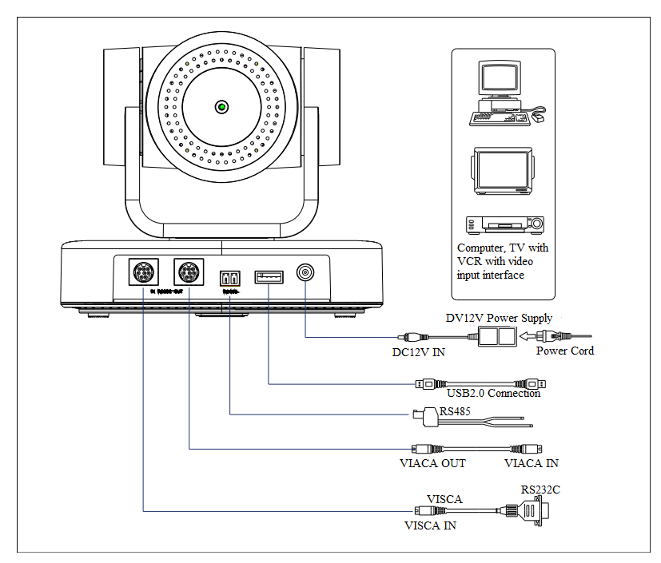
Figure2.4 Wiring Diagram

2.4.2 RS-232 Interface
1）RS-232 Interface Definition

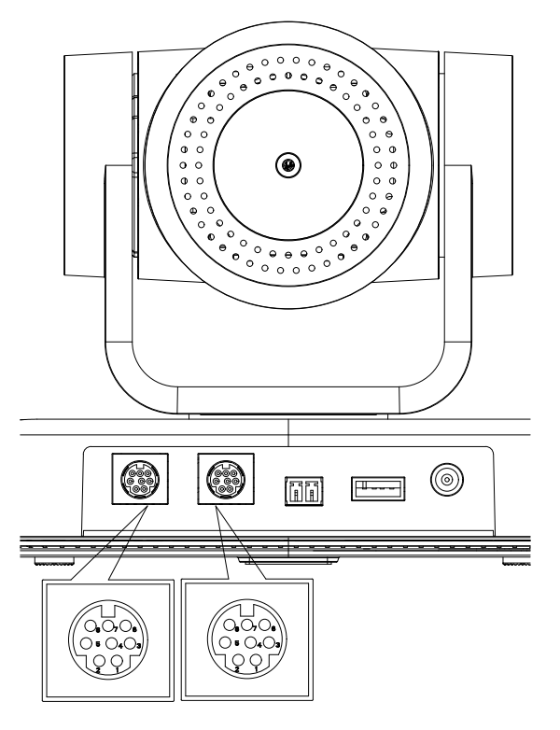 | Connection to PC or Camera Controller
 | Camera | WindowsDB-9
 | 1.DTR | 1.DCD
 | 2.DSR | 2.RXD
 | 3.TXD | 3.TXD
 | 4.GND | 4.DTR
 | 5.RXD | 5.GND
 | 6.GND | 6.DSR
 | 7.IR OUT | 7.RTS
 | 8.NC | 8.CTS
 |  | 9.RI
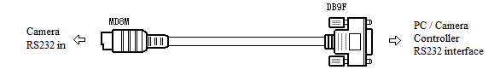

2）RS-232 Mini-DIN 8-pin Port Definition

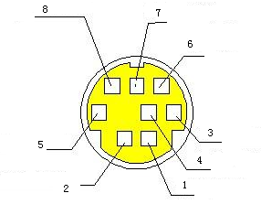 | NO. | Port | Definition
 | 1 | DTR | Data Terminal Ready
 | 2 | DSR | Data Set Ready
 | 3 | TXD | Transmit Data
 | 4 | GND | Signal Ground
 | 5 | RXD | Receive Data
 | 6 | GND | Signal Ground
 | 7 | IR OUT | IR Commander Signal
 | 8 | NC | No Connection

3）RS232(DB9) Port Definition

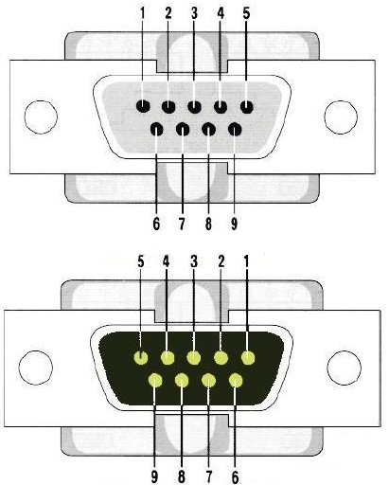 | NO. | Port | Definition
 | 1 | DCD | Data Carrier Detect
 | 2 | RXD | Receive Data
 | 3 | TXD | Transmit Data
 | 4 | DTR | Data Terminal Ready
 | 5 | GND | System Ground
 | 6 | DSR | Data Set Ready
 | 7 | RTS | Request to Send
 | 8 | CTS | Clear to Send
 | 9 | RI | Ring Indicator

4）VISCA networking as shown below

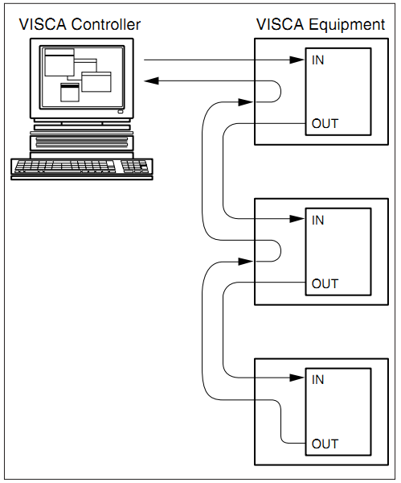 | Camera cascade connection
 | Camera 1 | Camera 2
 | 1.DTR | 1.DTR
 | 2.DSR | 2.DSR
 | 3.TXD | 3.TXD
 | 4.GND | 4.GND
 | 5.RXD | 5.RXD
 | 6.GND | 6.GND
 | 7.IR OUT | 7.OPEN
 | 8. NC | 8.OPEN

3. Application Instruction

3.1 Video Output

3.1.1 Power-On Initial Configuration
The remote control receiving indicator flashes after power on, the pan-tilt turns left to the lowest left to the lowest, and then turns to the HOME position (both the horizontal and vertical positions are in the middle), while the movement first shrinks and then stretches. When remote control receiving indicator stops flashing, the self-checking is completed. After power on and self-checking, the camera will automatically return to the preset 0 position if it’s pre-set.

3.1.2 Video Output
Connect to the video output cable: the user can refer to Figure 1.1 product interfaces.

USB2.0 output: Connect the camera with the computer USB2.0 interface (black), open the Device Manager to see whether there is an imaging device and whether the Universal Serial Bus controllers recognize the USB2.0 device. After properly identified, open the software, choose the imaging device, and then it will output the image.

3.2 Remote Control

3.2.1 Keys Introduction
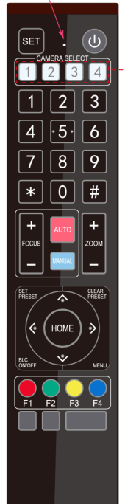 | 1) In this manual, “press the key” means a click rather than a long-press, and a special note will be given if a long-press for more than one second is required.  2) When a key-combination is required, do it in sequence. For example,“ 【*】+【#】+【F1】”means press“【*】”first and then press“【#】” and last press“【F1】”.  1. Standby Key  The camera enters standby mode if long press 3s on standby key;  Long press 3s again on the standby key, the camera will self-check again and return to HOME position (If preset 0 position is set, the camera will return to preset 0 position).  2. Camera Selection  Select the camera address to control  3. Number Keys  - * and # Keys  - Focus Control Keys: Adjust focus  [AUTO]: Enter into auto focus mode  [MANUAL]: Enter into manual focus mode. Press + or - to adjust focus  - Zoom Control  ZOOM +: press【ZOOM +】key to zoom in  ZOOM - : press 【ZOOM -】key to zoom out  - Set and Clear Presets  Set Preset: press 【SET PRESET】 button, and then press the number key 0-9 to set preset positions.  Clear Preset: press 【CLEAR PRESET】 button, and then press the number key 0-9 to clear preset positions.  - Pan/Tilt Control  Up: press Down: press  Left: press Right: press  “【HOME】”: Pan/Tilt back to the middle or enter into the next menu  - BLC Key  BLC on/off: Turn on/off BLC  - Menu Keys  Enter into/Exit OSD Menu or back to previous level menu
  .
  Set or call 0-9 number keys
- Camera Remote Control Address Setting
【*】+【＃】+【F1】:Camera Address No.1
【*】+【＃】+【F2】:Camera Address No. 2
【*】+【＃】+【F3】:Camera Address No. 3
【*】+【＃】+【F4】:Camera Address No. 4

3.2.2 Remote Usage

After the device starts normally, it receives and executes the infrared command, presses the button of the remote control, the remote control receiving indicator flashes, releases the button, the indicator stops flashing. You can use the infrared remote control to perform operations such as preset position setting, positioning, pan/tilt control.

Key Description:
1. The button mode mentioned in this manual refers to the two actions of pressing and releasing the buttons on the remote control. For example, "press the [HOME] key" refers to the action of pressing the [HOME] key and then release. If you need to press the key for a long time, it will be specially explained in the manual.
2. In this manual, when it is necessary to operate a combination key, it means to operate in the order of the manual. For example, "press【*】+【#】+【F1】key" means to press the【*】key first, then press the【#】key, and finally press the【F1】key.

- Camera Selection
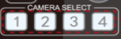 Choose the device address need to be controlled

- Pan/Tilt Control
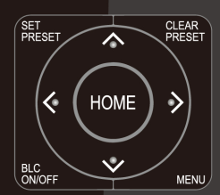 | Up: press Down: press  Left: press Right: press  Back to middle position: press“【HOME】”  Press and hold the up/down/left/right key, the pan/tilt movements will keep running, from slow to fast, until it runs to the endpoint; stop as soon as the key is released.

- Set and Clear Presets

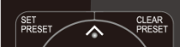 | Set Preset: press 【SET PRESET】 button, and then press the number key 0-9 to set preset positions.  Note: 10 presets via remote control.  Call Preset: Press a number key 0-9 directly to call a preset position.  Clear Preset: press 【CLEAR PRESET】 button, and then press the number key 0-9 to clear preset positions.  Note : press the【#】 key three times continually to clear all presets.

- Zoom Control
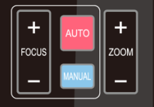 | ZOOM +: press【ZOOM +】key to zoom in  ZOOM - : press 【ZOOM -】key to zoom out  Press and hold the keys, the action of focus will keep continue and stop as soon as the key is released.

- Focus Control
[AUTO]: Enter into auto focus mode
[MANUAL]: Enter into manual focus mode. Press + or - to adjust focus

6. Camera Remote Control Address Setting
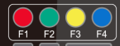 | 【*】+【＃】+【F1】:Camera Address No.1  【*】+【＃】+【F2】:Camera Address No. 2  【*】+【＃】+【F3】:Camera Address No. 3  【*】+【＃】+【F4】:Camera Address No. 4

3.3 Menu Introduction

3.3.1 Main Menu
In normal working mode, press 【MENU】 key to display the menu, using scroll arrow to point at or highlight the selected items.

MENU
＝＝＝＝＝＝＝＝＝＝＝＝＝＝＝＝
（Setup）
（Camera）
（P/T/Z）
（Version）
（Restore Default）

[↑↓]Select [← →]Change Value
[Menu]Back[Home]OK

Setup: System parameter setting
Camera: Camera parameter setting
P/T/Z: Enter into sub menu
Version: Enter into sub menu
Restore Default: Enter into reset setting, select YES or NO to confirm
[↑↓] Select: For selecting menu
[← →] Change Value: For modifying parameters
[MENU] Back: Press [Menu] to return
[Home] OK: Press [Home] to confirm

3.3.2 System Setting
Move the pointer to the (Setup) in the Main Menu, click the【HOME】key and enter into the (System Setting) as shown below,
SETUP
＝＝＝＝＝＝＝＝＝＝＝＝＝＝＝＝
Protocol Auto
Visca Address 1
Visca Address Fix OFF
PELCO-P Address 1
PELCO-D Address 1
Baudrate 9600
Auto Filp ON

[↑↓]Select [← →]Change Value
[Menu]Back

[↑↓]选择 [← →]修改
[菜单]返回

Protocol: VISCA/Pelco-P/Pelco-D/Auto
Visca Address: VISCA=1~7 Pelco-P=1~255 Pelco-D=1~255
Baudrate: 2400/4800/9600/115200
Visca Address Fix: On/Off
Auto Filp: On/Off

3.3.3 Camera Setting
Move the pointer to the (CAMERA) in the Main Menu, click the 【HOME】key and enter the (CAMERA) as follow,
CAMERA
＝＝＝＝＝＝＝＝＝＝＝＝＝＝＝＝＝
（Exposure）
（Color）
（Image）
（Focus）
（Noise Reduction）
Style Default
[↑↓]Select [← →]Change Value
[Menu]Back [Home]OK

Exposure: Enter into Exposure setting
Color: Enter into color setting
Image: Enter into image setting
Focus: Enter into focus setting
Noise Reduction: Enter into noise reduction

1）Exposure Setting
Move the pointer to the (EXPOSURE) in the Main Menu, click the【HOME】key and enter into the (Exposure sub menu) as shown below,

EXPOSURE
＝＝＝＝＝＝＝＝＝＝＝＝＝＝＝＝＝
Mode Auto
EV OFF
BLC OFF
Flicker 50Hz
G.Limit 3
DRC 2

[↑↓]Select [← →]Change Value
[Menu]Back

Mode: Auto, Manual, Shutter priority, Iris priority and Brightness priority.
EV: On/Off (only available in auto mode)
Compensation Level: -7~7 (only available in auto mode when EV is ON)
BLC: ON/OFF for options (only available in auto mode)
Dynamic Range: 1~8, close
Anti-Flicker: OFF/50Hz/60Hz for options (only available in Auto/Iris priority/Brightness priority modes)
Gain limit: 0~15 (only available in Auto/ Iris priority /Brightness priority mode)
WDR: Off, 1~8
ShutterPriority:1/25,1/30,1/50,1/60,1/90,1/100,1/120,1/180,1/250,1/350,1/500,1/1000,1/2000,1/3000,1/4000,1/6000, 1/10000 (only available in Manual and Shutter priority mode)
IRIS Priority: OFF, F11.0, F9.6, F8.0, F6.8, F5.6, F4.8, F4.0, F3.4, F2.8, F2.4, F2.0, F1.8(only available in Manual and Iris priority mode)
Brightness: 0~23 (only available in Brightness priority mode)
Gain: 0-15 (only available in Auto, and Shutter priority mode)

2）Color
Move the pointer to the (COLOR) in the Main Menu, click the【HOME】and enter the (COLOR sub menu) as follow,
COLOR
＝＝＝＝＝＝＝＝＝＝＝＝＝＝＝＝
WB Mode Auto
RG Tuning 0
BG Tuning 0
Saturation 36
Hue 4
AWB Sensitivity Low

[↑↓]Select [← →]Change Value
[Menu]Back

WB Mode: Auto, Manual, One Push, specified temperature color.
Saturation: 0-50 available
Red fine-tuning: -10~10 (only available in automatic mode)
Blue fine-tunable: -10~10 (only available in automatic mode)
RED GAIN: 0~255(only available in Manual mode)
BLUE GAIN: 0~255(only available in Manual mode)
Color Temperature: 2400K-7100K
AWB Sensitivity: high/middle/low
Hue: 0~8

3) Image
Move the pointer to the (IMAGE) in the Menu, click the【HOME】and enter into the (IMAGE sub menu) as follow,
IMAGE
＝＝＝＝＝＝＝＝＝＝＝＝＝＝＝＝
Brightness 50
Contrast 50
Sharpness 5
B&W-Mode Color
Gamma Default
DZoom Off
DCI Close
Low-Light Mode OFF
[↑↓]Select [← →]Change Value
[Menu]Back
Brightness: 0~100
Contrast: 0~100
Sharpness: 0~16
B&W Mode: color, black/white
DZoom: Off/On
Gamma: Default/0.45/0.50/0.56/0.63
DCI: Dynamic Contrast: Off/1～8
Minimum Illumination: On/Off

4）Focus
Move the pointer to the (FOCUS) in the Menu, click the【HOME】and enter the (FOCUS) as follow,
FOCUS
＝＝＝＝＝＝＝＝＝＝＝＝＝＝＝＝＝
Focus Mode Auto
AF-Zone All
AF-Sensitivity Low

[↑↓]Select [← →]Change Value
[Menu]Back

Focus Mode: Auto/manual
AF-Zone: Up/middle/down
AF-Sensitivity: High/middle/low

5）Noise Reduction
Move the pointer to the (NOISE REDUCTION) in the Menu, click the【HOME】and enter the (NOISE REDUCTION) as follow,

NOISE REDUCTION
＝＝＝＝＝＝＝＝＝＝＝＝＝＝＝＝＝
NR-2D2
NR-3D 4

[↑↓]Select [← →]Change Value
[Menu]Back

2D Noise Reduction: Auto, close, 1~7
3D Noise Reduction: Close, 1~8

3.3.4 P/T/Z
Move the pointer to the (P/T/Z) in the Main Menu, click the【HOME】and enter the (P/T/Z) as follow,

P/T/Z
＝＝＝＝＝＝＝＝＝＝＝＝＝＝＝＝
Speed by zoom ON
Zoom speed 8
Acc Curve Slow
Preset Speed 1

[↑↓]Select [← →]Change Value [Menu]Back

Depth of Field: Only effective for the remote controller, On/ Off;
(When zooming in, the PT control speed by remoter will become slow)
Zoom Speed: Set the zoom speed for the remote controller, 1~8
Image Freezing: On/Off
Accelerating Curve: Fast/Slow
Preset Speed: This value will not be changed into default due to factory restore

3.3.5 Version
Move the pointer to the (VERSION) in the Main Menu, click the【HOME】and enter the (VERSION) as follow,

VERSION
＝＝＝＝＝＝＝＝＝＝＝＝＝＝＝＝＝
MCU Version 3.1.0 2021-10-27
Camera Version 1.0.0 2021-11-15
AF Version 1.0.0 2021-01-12

[↑↓]Select [← →]Change Value
[Menu]Back [Home]OK

MCU Version: Display MCU version information
Camera Version: Display camera version information
AF Version: Display the focus version information

3.3.6 Restore Default
Move the pointer to the (RESTORE DEFAULT) in the Main Menu, click the【HOME】and enter the (RESTORE DEFAULT) as follow,

RESTORE DEFAULT
＝＝＝＝＝＝＝＝＝＝＝＝＝＝＝＝＝
Restore Default? NO

[↑↓]Select [← →]Change Value
[Menu]Back [Home]OK

Restore default: YES/NO. Color style and video format cannot be restored to factory default

Note: If the address of former remoter is not 1 but another one from 2, 3, 4, the corresponding camera address will restore to 1 when all parameters or system parameters are restored. User should change the remoter address to be 1 (press No.1 according to the camera so to get normal operation).

4. Serial Port Communication and Control

The camera could be controlled through RS232/RS485 interface; RS232C serial parameter are as follows:
Baud rate: 2400/4800/9600/115200 bits / sec; Start bit: 1; data bits: 8; Stop bit: 1; Parity: None.

After power on, the camera first goes left, then back to the middle position. Self-test is finished after the zoom moved to the farthest and then back to the nearest position. If the camera saved 0 preset before, it will be back to that position after initialization. At this point, the user can control the camera by the serial commands.

4.1 VISCA Protocol list

4.1.1 VISCA Protocol Return Command
Ack/Completion Message
 | Command packet | Note
ACK | z0 41 FF | Returned when the command is accepted.
Completion | z0 51 FF | Returned when the command has been executed.
z = camera address + 8
Error Messages
 | Command packet | Note
Syntax Error | z0 60 02 FF | Returned when the command format is different or when a command with illegal command parameters is accepted
Command Not Executable | z0 61 41 FF | Returned when a command cannot be executed due to current conditions. For example, when commands controlling the focus manually are received during auto focus.

4.1.2 VISCA Protocol Control Command
Command | Function | Command packet | Note
AddressSet | Broadcast | 88 30 0p FF | p：Address setting
IF_Clear | Broadcast | 88 01 00 01 FF | I/F Clear
CommandCancel |  | 8x 21 FF
CAM_Power | On | 8x 01 04 00 02 FF | Power ON/OFF
CAM_Power | Off | 8x 01 04 00 03 FF | Power ON/OFF
CAM_Zoom | Stop | 8x 01 04 07 00 FF
CAM_Zoom | Tele(Standard) | 8x 01 04 07 02 FF
CAM_Zoom | Wide(Standard) | 8x 01 04 07 03 FF
CAM_Zoom | Tele(Variable) | 8x 01 04 07 2p FF | p = 0(low) - F(high)
CAM_Zoom | Wide(Variable) | 8x 01 04 07 3p FF | p = 0(low) - F(high)
CAM_Zoom | Direct | 8x 01 04 47 0p 0q 0r 0s FF | pqrs: Zoom Position
CAM _Focus | Stop | 8x 01 04 08 00 FF
CAM _Focus | Far(Standard) | 8x 01 04 08 02 FF
CAM _Focus | Near(Standard) | 8x 01 04 08 03 FF
CAM _Focus | Far(Variable) | 8x 01 04 08 2p FF | p = 0(low) - F(high)
CAM _Focus | Near (Variable) | 8x 01 04 08 3p FF | p = 0(low) - F(high)
CAM _Focus | Direct | 8x 01 04 48 0p 0q 0r 0s FF | pqrs: Focus Position
CAM _Focus | Auto Focus | 8x 01 04 38 02 FF
CAM _Focus | Manual Focus | 8x 01 04 38 03 FF
CAM _Focus | One Push mode | 8x 01 04 38 04 FF
CAM _Zoom Focus | Direct | 8x 01 04 47 0p 0q 0r 0s  0t 0u 0v 0w FF | pqrs: Zoom Position  tuvw: Focus Position
CAM_WB | Auto | 8x 01 04 35 00 FF
CAM_WB | 3000K | 8x 01 04 35 01 FF
CAM_WB | 4000k | 8x 01 04 35 02 FF
CAM_WB | One Push mode | 8x 01 04 35 03 FF
CAM_WB | 5000k | 8x 01 04 35 04 FF
CAM_WB | Manual | 8x 01 04 35 05 FF
CAM_WB | 6500k | 8x 01 04 35 06 FF
CAM_WB | 3500K | 8x 01 04 35 07 FF
CAM_WB | 4500K | 8x 01 04 35 08 FF
CAM_WB | 5500K | 8x 01 04 35 09 FF
CAM_WB | 6000K | 8x 01 04 35 0A FF
CAM_WB | 7000K | 8x 01 04 35 0B FF
CAM _RGain | Reset | 8x 01 04 03 00 FF | Manual Control of R Gain
CAM _RGain | Up | 8x 01 04 03 02 FF | Manual Control of R Gain
CAM _RGain | Down | 8x 01 04 03 03 FF | Manual Control of R Gain
CAM _RGain | Direct | 8x 01 04 43 00 00 0p 0q FF | pq: R Gain
CAM_ Bgain | Reset | 8x 01 04 04 00 FF | Manual Control of B Gain
CAM_ Bgain | Up | 8x 01 04 04 02 FF | Manual Control of B Gain
CAM_ Bgain | Down | 8x 01 04 04 03 FF | Manual Control of B Gain
CAM_ Bgain | Direct | 8x 01 04 44 00 00 0p 0q FF | pq: B Gain
CAM_AE | Full Auto | 8x 01 04 39 00 FF | Automatic Exposure mode
CAM_AE | Manual | 8x 01 04 39 03 FF | Manual Control mode
CAM_AE | Shutter priority | 8x 01 04 39 0A FF | Shutter Priority Automatic Exposure mode
CAM_AE | Iris priority | 8x 01 04 39 0B FF | Iris Priority Automatic Exposure mode
CAM_AE | Bright | 8x 01 04 39 0D FF | Bright mode
CAM_Shutter | Reset | 8x 01 04 0A 00 FF | Shutter Setting
CAM_Shutter | Up | 8x 01 04 0A 02 FF | Shutter Setting
CAM_Shutter | Down | 8x 01 04 0A 03 FF | Shutter Setting
CAM_Shutter | Direct | 8x 01 04 4A 00 00 0p 0q FF | pq: Shutter Position
CAM_Iris | Reset | 8x 01 04 0B 00 FF | Iris Setting
CAM_Iris | Up | 8x 01 04 0B 02 FF | Iris Setting
CAM_Iris | Down | 8x 01 04 0B 03 FF | Iris Setting
CAM_Iris | Direct | 8x 01 04 4B 00 00 0p 0q FF | pq: Iris Position
CAM_Gain Limit | Gain Limit | 8x 01 04 2C 0p FF | p: Gain Positon
CAM_Bright | Reset | 8x 01 04 0D 00 FF | Bright Setting
CAM_Bright | Up | 8x 01 04 0D 02 FF | Bright Setting
CAM_Bright | Down | 8x 01 04 0D 03 FF | Bright Setting
CAM_Bright | Direct | 8x 01 04 4D 00 00 0p 0q FF | pq: Bright Positon
CAM_ExpComp | On | 8x 01 04 3E 02 FF | Exposure Compensation ON/OFF
CAM_ExpComp | Off | 8x 01 04 3E 03 FF | Exposure Compensation ON/OFF
CAM_ExpComp | Reset | 8x 01 04 0E 00 FF | Exposure Compensation Amount Setting
CAM_ExpComp | Up | 8x 01 04 0E 02 FF | Exposure Compensation Amount Setting
CAM_ExpComp | Down | 8x 01 04 0E 03 FF | Exposure Compensation Amount Setting
CAM_ExpComp | Direct | 8x 01 04 4E 00 00 0p 0q FF | pq: ExpComp Position
CAM_Back Light | On | 8x 01 04 33 02 FF | Back Light  Compensation
CAM_Back Light | Off | 8x 01 04 33 03 FF | Back Light  Compensation
CAM_WDRStrength | Reset | 8x 01 04 21 00 FF | WDR Level Setting
CAM_WDRStrength | Up | 8x 01 04 21 02 FF | WDR Level Setting
CAM_WDRStrength | Down | 8x 01 04 21 03 FF | WDR Level Setting
CAM_WDRStrength | Direct | 8x 01 04 51 00 00 00 0p FF | p: WDR Level Positon
CAM_NR（2D） |  | 8x 01 04 53 0p FF | P=0-7 0:OFF
CAM_NR（3D） |  | 8x 01 04 54 0p FF | P=0-8 0:OFF
CAM_Gamma |  | 8x 01 04 5B 0p FF | p = 0 – 4 0：Default 1：0.45 2：0.50 3：0.55 4：0.63
CAM_Flicker | OFF | 8x 01 04 23 00 FF | OFF
CAM_Flicker | 50HZ | 8x 01 04 23 01 FF | 50HZ
CAM_Flicker | 60HZ | 8x 01 04 23 02 FF | 60HZ
CAM_Aperture | Reset | 8x 01 04 02 00 FF | Aperture Control
CAM_Aperture | Up | 8x 01 04 02 02 FF | Aperture Control
CAM_Aperture | Down | 8x 01 04 02 03 FF | Aperture Control
CAM_Aperture | Direct | 8x 01 04 42 00 00 0p 0q FF | pq: Aperture Gain
CAM_Memory | Reset | 8x 01 04 3F 00 pq FF | pq: Memory Number(=0 to 254)  Corresponds to 0 to 9 on the Remote Commander
CAM_Memory | Set | 8x 01 04 3F 01 pq FF
CAM_Memory | Recall | 8x 01 04 3F 02 pq FF
CAM_LR_Reverse | On | 8x 01 04 61 02 FF | Image Flip Horizontal ON/OFF
CAM_LR_Reverse | Off | 8x 01 04 61 03 FF | Image Flip Horizontal ON/OFF
CAM_PictureFlip | On | 8x 01 04 66 02 FF | Image Flip Vertical ON/OFF
CAM_PictureFlip | Off | 8x 01 04 66 03 FF | Image Flip Vertical ON/OFF
CAM_ColorSaturation | Direct | 8x 01 04 49 00 00 00 0p FF | P=0-E  0:60% 1:70% 2:80% 3:90% 4:100% 5:110% 6:120% 7:130% 8:140% 9:150% 10:160% 11:160% 12:180% 13:190% 14:200%
CAM_IDWrite |  | 8x 01 04 22 0p 0q 0r 0s FF | pqrs: Camera ID (=0000 to FFFF)
SYS_Menu | ON | 8x 01 04 06 06 02 FF | Turn on the menu screen
SYS_Menu | OFF | 8x 01 04 06 06 03 FF | Turn off the menu screen
IR_Receive | ON | 8x 01 06 08 02 FF | IR(remote commander)receive On/Off
IR_Receive | OFF | 8x 01 06 08 03 FF | IR(remote commander)receive On/Off
IR_ReceiveReturn | On | 8x 01 7D 01 03 00 00 FF | IR(remote commander)receive message via the VISCA communication ON/OFF
IR_ReceiveReturn | Off | 8x 01 7D 01 13 00 00 FF
CAM_SettingReset | Reset | 8x 01 04 A0 10 FF | Reset Factory Setting
CAM_Brightness | Direct | 8x 01 04 A1 00 00 0p 0q FF | pq: Brightness Position
CAM_Contrast | Direct | 8x 01 04 A2 00 00 0p 0q FF | pq: Contrast Position
CAM_Flip | OFF | 8x 01 04 A4 00 FF | Single Command For Video Flip
CAM_Flip | Flip-H | 8x 01 04 A4 01 FF | Single Command For Video Flip
CAM_Flip | Flip-V | 8x 01 04 A4 02 FF | Single Command For Video Flip
CAM_Flip | Flip-HV | 8x 01 04 A4 03 FF | Single Command For Video Flip
CAM_VideoSystem | Set camera video system | 8x 01 06 35 00 0p FF | P: 0~E Video format  0:1080P60 8:720P30  1:1080P50 9:720P25  2:1080i60 A：1080P59.94  3:1080i50 B：1080i59.94  4:720P60 C：720P59.94  5:720P50 D：1080P29.97  6:1080P30 E：720P29.97  7:1080P25
Pan_tiltDrive | Up | 8x 01 06 01 VV WW 03 01 FF | VV: Pan speed 0x01 (low speed) to 0x18 (high speed)  WW: Tilt speed 0x01 (low speed) to 0x14 (high speed)  YYYY: Pan Position  ZZZZ: Tilt Position
Pan_tiltDrive | Down | 8x 01 06 01 VV WW 03 02 FF
Pan_tiltDrive | Left | 8x 01 06 01 VV WW 01 03 FF
Pan_tiltDrive | Right | 8x 01 06 01 VV WW 02 03 FF
Pan_tiltDrive | Upleft | 8x 01 06 01 VV WW 01 01 FF
Pan_tiltDrive | Upright | 8x 01 06 01 VV WW 02 01 FF
Pan_tiltDrive | DownLeft | 8x 01 06 01 VV WW 01 02 FF
Pan_tiltDrive | DownRight | 8x 01 06 01 VV WW 02 02 FF
Pan_tiltDrive | Stop | 8x 01 06 01 VV WW 03 03 FF
Pan_tiltDrive | AbsolutePosition | 8x 01 06 02 VV WW  0Y 0Y 0Y 0Y 0Z 0Z 0Z 0Z FF
Pan_tiltDrive | RelativePosition | 8x 01 06 03 VV WW  0Y 0Y 0Y 0Y 0Z 0Z 0Z 0Z FF
Pan_tiltDrive | Home | 8x 01 06 04 FF
Pan_tiltDrive | Reset | 8x 01 06 05 FF
Pan-tiltLimitSet | Set | 8x 01 06 07 00 0W  0Y 0Y 0Y 0Y 0Z 0Z 0Z 0Z FF | W:1 UpRight 0:DownLeft  YYYY: Pan Limit Position(TBD)  ZZZZ: Tilt Limit Position(TBD)
Pan-tiltLimitSet | Clear | 8x 01 06 07 01 0W  07 0F 0F 0F 07 0F 0F 0F FF

4.1.3 VISCA Protocol Inquiry Command
Command | Command Packet | Return Packet | Note
CAM_PowerInq | 8x 09 04 00 FF | y0 50 02 FF | On
CAM_PowerInq | 8x 09 04 00 FF | y0 50 03 FF | Off(Standby)
CAM_ZoomPosInq | 8x 09 04 47 FF | y0 50 0p 0q 0r 0s FF | pqrs: Zoom Position
CAM_FocusAFModeInq | 8x 09 04 38 FF | y0 50 02 FF | Auto Focus
CAM_FocusAFModeInq | 8x 09 04 38 FF | y0 50 03 FF | Manual Focus
CAM_FocusAFModeInq | 8x 09 04 38 FF | y0 50 04 FF | One Push mode
CAM_FocusPosInq | 8x 09 04 48 FF | y0 50 0p 0q 0r 0s FF | pqrs: Focus Position
CAM_WBModeInq | 8x 09 04 35 FF | y0 50 00 FF | Auto
CAM_WBModeInq | 8x 09 04 35 FF | y0 50 01 FF | 3000K
CAM_WBModeInq | 8x 09 04 35 FF | y0 50 02 FF | 4000K
CAM_WBModeInq | 8x 09 04 35 FF | y0 50 03 FF | One Push Mode
CAM_WBModeInq | 8x 09 04 35 FF | y0 50 04 FF | 5000K
CAM_WBModeInq | 8x 09 04 35 FF | y0 50 05 FF | Manual
CAM_WBModeInq | 8x 09 04 35 FF | y0 50 00 FF | 6500K
CAM_WBModeInq | 8x 09 04 35 FF | y0 50 06 FF | 6500K
CAM_WBModeInq | 8x 09 04 35 FF | y0 50 07 FF | 3500K
CAM_WBModeInq | 8x 09 04 35 FF | y0 50 08 FF | 4500K
CAM_WBModeInq | 8x 09 04 35 FF | y0 50 09 FF | 5500K
CAM_WBModeInq | 8x 09 04 35 FF | y0 50 0A FF | 6000K
CAM_RGainInq | 8x 09 04 43 FF | y0 50 0B FF | 7000K
CAM_BGainInq | 8x 09 04 44 FF | y0 50 00 00 0p 0q FF | pq: B Gain
CAM_AEModeInq | 8x 09 04 39 FF | y0 50 00 FF | Full Auto
CAM_AEModeInq | 8x 09 04 39 FF | y0 50 03 FF | Manual
CAM_AEModeInq | 8x 09 04 39 FF | y0 50 0A FF | Shutter priority
CAM_AEModeInq | 8x 09 04 39 FF | y0 50 0B FF | Iris priority
CAM_AEModeInq | 8x 09 04 39 FF | y0 50 0D FF | Bright
CAM_ShutterPosInq | 8x 09 04 4A FF | y0 50 00 00 0p 0q FF | pq: Shutter Position
CAM_IrisPosInq | 8x 09 04 4B FF | y0 50 00 00 0p 0q FF | pq: Iris Position
CAM_Gain LimitInq | 8x 09 04 2C FF | y0 50 0p FF | p: Gain Positon
CAM_ BrightPosiInq | 8x 09 04 4D FF | y0 50 00 00 0p 0q FF | pq: Bright Position
CAM_ExpCompModeInq | 8x 09 04 3E FF | y0 50 02 FF | On
CAM_ExpCompModeInq | 8x 09 04 3E FF | y0 50 03 FF | Off
CAM_ExpCompPosInq | 8x 09 04 4E FF | y0 50 00 00 0p 0q FF | pq: ExpComp Position
CAM_BacklightModeInq | 8x 09 04 33 FF | y0 50 02 FF | On
CAM_BacklightModeInq | 8x 09 04 33 FF | y0 50 03 FF | Off
CAM_WDRStrengthInq | 8x 09 04 51 FF | y0 50 00 00 00 0p FF | p: WDR Strength
CAM_NRLevel(2D) Inq | 8x 09 04 53 FF | y0 50 0p FF | P: 2DNRLevel
CAM_NRLevel(3D) Inq | 8x 09 04 54 FF | y0 50 0p FF | P:3D NRLevel
CAM_FlickerModeInq | 8x 09 04 55 FF | y0 50 0p FF | p: Flicker Settings(0: OFF, 1: 50Hz, 2:60Hz)
CAM_ApertureInq | 8x 09 04 42 FF | y0 50 00 00 0p 0q FF | pq: Aperture Gain
CAM_PictureEffectModeInq | 8x 09 04 63 FF | y0 50 00 FF | Off
CAM_PictureEffectModeInq | 8x 09 04 63 FF | y0 50 04 FF | B&W
CAM_MemoryInq | 8x 09 04 3F FF | y0 50 0p FF | p: Memory number last operated.
SYS_MenuModeInq | 8x 09 06 06 FF | y0 50 02 FF | On
SYS_MenuModeInq | 8x 09 06 06 FF | y0 50 03 FF | Off
CAM_LR_ReverseInq | 8x 09 04 61 FF | y0 50 02 FF | On
CAM_LR_ReverseInq | 8x 09 04 61 FF | y0 50 03 FF | Off
CAM_PictureFlipInq | 8x 09 04 66 FF | y0 50 02 FF | On
CAM_PictureFlipInq | 8x 09 04 66 FF | y0 50 03 FF | Off
CAM_ColorSaturationInq | 8x 09 04 49 FF | y0 50 00 00 00 0p FF | p: Color Gain setting 0h (60%) to Eh (130%)
CAM_IDInq | 8x 09 04 22 FF | y0 50 0p FF | p: Gamma ID
IR_ReceiveInq | 8x 09 06 08 FF | y0 50 02 FF | On
IR_ReceiveInq | 8x 09 06 08 FF | y0 50 03 FF | Off
IR_ReceiveReturn |  | y0 07 7D 01 04 00 FF | Power ON/OFF
IR_ReceiveReturn |  | y0 07 7D 01 04 07 FF | Zoom tele/wide
IR_ReceiveReturn |  | y0 07 7D 01 04 38 FF | AF ON/OFF
IR_ReceiveReturn |  | y0 07 7D 01 04 33 FF | Camera _Backlight
IR_ReceiveReturn |  | y0 07 7D 01 04 3F FF | Camera _Memery
IR_ReceiveReturn |  | y0 07 7D 01 06 01 FF | Pan_titleDriver
CAM_BrightnessInq | 8x 09 04 A1 FF | y0 50 00 00 0p 0q FF | pq: Brightness Position
CAM_ContrastInq | 8x 09 04 A2 FF | y0 50 00 00 0p 0q FF | pq: Contrast Position
CAM_FlipInq | 8x 09 04 A4 FF | y0 50 00 FF | Off
CAM_FlipInq | 8x 09 04 A4 FF | y0 50 01 FF | Flip-H
CAM_FlipInq | 8x 09 04 A4 FF | y0 50 02 FF | Flip-V
CAM_FlipInq | 8x 09 04 A4 FF | y0 50 03 FF | Flip-HV
CAM_GammaInq | 8x 09 04 5B FF | y0 50 0p FF | p: Gamma setting
CAM_VersionInq | 8x 09 00 02 FF | y0 50 ab cd  mn pq rs tu vw FF | ab cd : vender ID ( 0220 )  mn pq : model ID ST ( 0510 ) 、  U2( 0512 )、U3 ( 0513 )  rs tu : ARM Version  vw : reserve
VideoSystemInq | 8x 09 06 23 FF | y0 50 0p FF | P: 0~E Video format  0:1080P60 8:720P30  1:1080P50 9:720P25  2:1080i60 A：1080P59.94  3:1080i50 B：1080i59.94  4:720P60 C：720P59.94  5:720P50 D：1080P29.97  6:1080P30 E：720P29.97  7:1080P25
Pan-tiltMaxSpeedInq | 8x 09 06 11 FF | y0 50 ww zz FF | ww: Pan Max Speed zz: Tilt Max Speed
Pan-tiltPosInq | 8x 09 06 12 FF | y0 50 0w 0w 0w 0w  0z 0z 0z 0z FF | wwww: Pan Position zzzz: Tilt Position

Note:[X] in the above table indicates the camera address to be operated,【y】=【x + 8】.

4.2 Pelco-D Protocol Command List
Function | Byte1 | Byte2 | Byte3 | Byte4 | Byte5 | Byte6 | Byte7
Up | 0xFF | Address | 0x00 | 0x08 | Pan Speed | Tilt Speed | SUM
Down | 0xFF | Address | 0x00 | 0x10 | Pan Speed | Tilt Speed | SUM
Left | 0xFF | Address | 0x00 | 0x04 | Pan Speed | Tilt Speed | SUM
Right | 0xFF | Address | 0x00 | 0x02 | Pan Speed | Tilt Speed | SUM
Upleft | 0xFF | Address | 0x00 | 0x0C | Pan Speed | Tilt Speed | SUM
Upright | 0xFF | Address | 0x00 | 0x0A | Pan Speed | Tilt Speed | SUM
DownLeft | 0xFF | Address | 0x00 | 0x14 | Pan Speed | Tilt Speed | SUM
DownRight | 0xFF | Address | 0x00 | 0x12 | Pan Speed | Tilt Speed | SUM
Zoom In | 0xFF | Address | 0x00 | 0x20 | 0x00 | 0x00 | SUM
Zoom Out | 0xFF | Address | 0x00 | 0x40 | 0x00 | 0x00 | SUM
Focus Far | 0xFF | Address | 0x00 | 0x80 | 0x00 | 0x00 | SUM
Focus Near | 0xFF | Address | 0x01 | 0x00 | 0x00 | 0x00 | SUM
Stop | 0xFF | Address | 0x00 | 0x00 | 0x00 | 0x00 | SUM
Set Preset | 0xFF | Address | 0x00 | 0x03 | 0x00 | Preset ID | SUM
Clear Preset | 0xFF | Address | 0x00 | 0x05 | 0x00 | Preset ID | SUM
Call Preset | 0xFF | Address | 0x00 | 0x07 | 0x00 | Preset ID | SUM
Query Pan Position | 0xFF | Address | 0x00 | 0x51 | 0x00 | 0x00 | SUM
Query Pan Position Response | 0xFF | Address | 0x00 | 0x59 | Value High Byte | Value Low Byte | SUM
Query Tilt Position | 0xFF | Address | 0x00 | 0x53 | 0x00 | 0x00 | SUM
Query Tilt Position Response | 0xFF | Address | 0x00 | 0x5B | Value High Byte | Value Low Byte | SUM
Query Zoom Position | 0xFF | Address | 0x00 | 0x55 | 0x00 | 0x00 | SUM
Query Zoom Position Response | 0xFF | Address | 0x00 | 0x5D | Value High Byte | Value Low Byte | SUM

4.3 Pelco-P Protocol Command List
Function | Byte1 | Byte2 | Byte3 | Byte4 | Byte5 | Byte6 | Byte7 | Byte8
Up | 0xA0 | Address | 0x00 | 0x08 | Pan Speed | Tilt Speed | 0xAF | XOR
Down | 0xA0 | Address | 0x00 | 0x10 | Pan Speed | Tilt Speed | 0xAF | XOR
Left | 0xA0 | Address | 0x00 | 0x04 | Pan Speed | Tilt Speed | 0xAF | XOR
Right | 0xA0 | Address | 0x00 | 0x02 | Pan Speed | Tilt Speed | 0xAF | XOR
Upleft | 0xA0 | Address | 0x00 | 0x0C | Pan Speed | Tilt Speed | 0xAF | XOR
Upright | 0xA0 | Address | 0x00 | 0x0A | Pan Speed | Tilt Speed | 0xAF | XOR
DownLeft | 0xA0 | Address | 0x00 | 0x14 | Pan Speed | Tilt Speed | 0xAF | XOR
DownRight | 0xA0 | Address | 0x00 | 0x12 | Pan Speed | Tilt Speed | 0xAF | XOR
Zoom In | 0xA0 | Address | 0x00 | 0x20 | 0x00 | 0x00 | 0xAF | XOR
Zoom Out | 0xA0 | Address | 0x00 | 0x40 | 0x00 | 0x00 | 0xAF | XOR
Stop | 0xA0 | Address | 0x00 | 0x00 | 0x00 | 0x00 | 0xAF | XOR
Focus Far | 0xA0 | Address | 0x01 | 0x00 | 0x00 | 0x00 | 0xAF | XOR
Focus Near | 0xA0 | Address | 0x02 | 0x00 | 0x00 | 0x00 | 0xAF | XOR
Set Preset | 0xA0 | Address | 0x00 | 0x03 | 0x00 | Preset ID | 0xAF | XOR
Clear Preset | 0xA0 | Address | 0x00 | 0x05 | 0x00 | Preset ID | 0xAF | XOR
Call Preset | 0xA0 | Address | 0x00 | 0x07 | 0x00 | Preset ID | 0xAF | XOR
Query Pan Position | 0xA0 | Address | 0x00 | 0x51 | 0x00 | 0x00 | 0xAF | XOR
Query Pan Position Response | 0xA0 | Address | 0x00 | 0x59 | Value High Byte | Value Low Byte | 0xAF | XOR
Query Tilt Position | 0xA0 | Address | 0x00 | 0x53 | 0x00 | 0x00 | 0xAF | XOR
Query Tilt Position Response | 0xA0 | Address | 0x00 | 0x5B | Value High Byte | Value Low Byte | 0xAF | XOR
Query Zoom Position | 0xA0 | Address | 0x00 | 0x55 | 0x00 | 0x00 | 0xAF | XOR
Query Zoom Position Response | 0xA0 | Address | 0x00 | 0x5D | Value High Byte | Value Low Byte | 0xAF | XOR

5. Maintenance and Troubleshooting

5.1 Camera Maintenance
1) Please power off the camera and disconnect the power adapter and socket, if it’s not used for a long run.
2) Use soft cloth or tissue to clean the camera cover.
3) Wipe it with a soft, dry cloth when cleaning the camera lens. Wipe it gently with a mild detergent if needed. Do not use strong or corrosive detergents to avoid scratching the lens and affecting the video quality.

5.2 Troubleshooting
- No video output
a. Check whether the camera power supply is connected, the voltage is normal, the power indicator is lit.
b. Whether the machine could do self-check after restarted.
c. Check whether the bottom of the DIP switch is the normal operating mode (see Table 2.2 and Table 2.3)
d. Check whether the video output cable or video display is normal

2) No image sometimes
a. Check whether the video output cable or video display is normal

3) Video dithering when zoom-in or zoom-out
a. Check whether the camera installation position is solid
b. Whether there is shaking machine or objects around the camera

4) Remote control not works
a. Remote control address is set to 1 (if the machine is set back to the factory defaults, remote control addresses need to be back to 1 too)
b. Check whether the battery is installed on the remote controller or low.
c, Check the camera working mode is the normal operating mode (see Table 2.2 and Table 2.3)
d. Check the menu whether is closed, camera control through remote controller is only available after exiting the menu. If video output from LAN, menu will not be displayed, menu will automatically exists 30s later, and then it can be controlled by remote controller.

- Serial port not works
a. Check whether the camera serial device protocol, baud rate, address is consistent
b. Check whether the control cable is connected properly
c. Check whether the camera working mode is the normal operating mode (see Table 2.2 and Table 2.3)

6. Copyright Statement

All the contents in this manual and its copyright are owned by the company. No one is allowed to imitate, copy, or translate this manual without the company’s permission. This manual contains no guarantee, standpoint expression or other implies in any form. Product specification and information in this manual is for reference only and subject to change without notice.
All rights reserved. No reproducing is allowed without acknowledgement.

